AIM :- To develop a home page
<!DOCTYPE html>
<html lang="en">
<head>
<meta charset="UTF-8">
<meta name="viewport" content="width=device-width, initial-scale=1.0">
<title>Web Site Layout</title>
<style>
body {
font-family: Arial, sans-serif;
margin: 10px;
padding: 10px;
}
table {
width: 100%;
border-collapse: collapse;
}
.header-cell, .side-nav-cell, .content-cell {
padding: 10px;
border: 1px solid black;
}
.header-cell {
background-color: #f0c19e;
text-align: center;
font-weight: bold;
}
.header-row td {
text-align: center;
padding: 10px;
margin: 10px;
border: 1px solid black;
}
.side-nav-cell {
width: 15%;
vertical-align: top;
}
.content-cell {
text-align: center;
}
.side-nav-cell a {
display: block;
margin-bottom: 10px;
text-decoration: none;
color: #000;
}
</style>
</head>
<body>

<table>
<tr class="header-row">
<td class="header-cell">Logo</td>
<td colspan="5" class="header-cell">Web Site Name</td>
</tr>

<tr class="header-row">
<td>Home</td>
<td>Login</td>
<td>Registration</td>
<td>Catalogue</td>
<td>Cart</td>
</tr>

<tr>
<td class="side-nav-cell">
<a href="#cse">CSE</a>
<a href="#ece">ECE</a>
<a href="#eee">EEE</a>
<a href="#civil">CIVIL</a>
</td>
<td colspan="5" class="content-cell">
Description of the WebSite
</td>
</tr>
</table>

</body>
</html>

OUTPUT :-

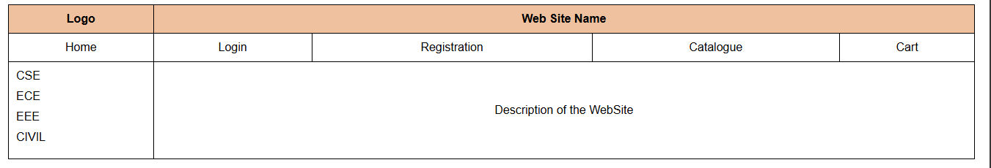

AIM :- To develop a login page
<!DOCTYPE html>
<html lang="en">
<head>
<meta charset="UTF-8">
<meta name="viewport" content="width=device-width, initial-scale=1.0">
<title>Web Site Layout</title>
<style>
body {
font-family: Arial, sans-serif;
margin: 10px;
padding: 10px;
}
table {
width: 100%;
border-collapse: collapse;
}
.header-cell, .side-nav-cell, .content-cell {
padding: 10px;
border: 1px solid black;
}
.header-cell {
background-color: #f0c19e;
text-align: center;
font-weight: bold;
}
.header-row td {
text-align: center;
padding: 10px;
margin: 10px;
border: 1px solid black;
}
.side-nav-cell {
width: 15%;
vertical-align: top;
}
.content-cell {
text-align: center;
}
.side-nav-cell a {
display: block;
margin-bottom: 10px;
text-decoration: none;
color: #000;
}
</style>
</head>
<body>

<table>
<tr class="header-row">
<td class="header-cell">Logo</td>
<td colspan="5" class="header-cell">Web Site Name</td>
</tr>

<tr class="header-row">
<td>Home</td>
<td>Login</td>
<td>Registration</td>
<td>Catalogue</td>
<td>Cart</td>
</tr>

<tr>
<td class="side-nav-cell">
<a href="#cse">CSE</a>
<a href="#ece">ECE</a>
<a href="#eee">EEE</a>
<a href="#civil">CIVIL</a>
</td>
<td colspan="5" class="content-cell">
<h3>Login Page</h3>
<form>
User Name:
<input type="text" name="username"><br><br>
Password:
<input type="password" name="password"><br><br>
<input type="submit" value="Submit">
<input type="reset" value="Reset">
</form>
</td>
</tr>
</table>

</body>
</html>
OUTPUT :-
